WDS600-104 series EPON ONU(Includes Wi-Fi series)
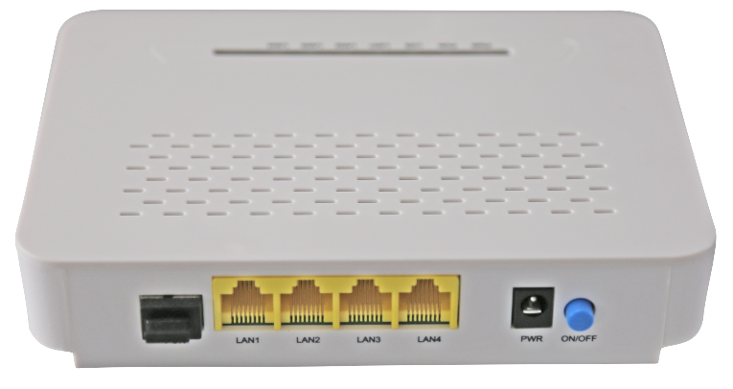

Brief Views
WDS600-104 series is C-Data’s for broadband access market based on the introduction of EPON technology passive optical network terminal products. It’s with EPON OLT are used together to provide a complete broadband access solution.
EPON technology is a kind of emerging technology which takes advantage of PON technology and Ethernet technology also is a kind of point to multi-point network technology. OLT through the passive optical network to connect multiple ONU with single fiber bidirectional technical can rarely used fiber resources to meet the operators of the multi-user access requirements.
WDS600-104 series fully meet IEE802.3ah and CTC3.0 standard protocol. It has good third-party compatibility to work with the third party OLT, It supports 1Gbps transmission rate up and down and provides users with good QOS, flexible bandwidth allocation of Ethernet services and IP integrated service.
WDS600-104 series can integration wireless function with meet 802.11 n/b/g technical standards, It has built-in high gain directional antenna, the wireless transmission rate up to 300Mbps. It has the characteristics of strong penetrating power and wide coverage. It can provide users with more efficient data transmission security.

Functional Feature
  - Support port-based rate limitation and bandwidth control;
  - In compliant with IEEE802.3ah Standard
  - Wi-Fi series meet 802.11 n/b/g technical standards
  - Up to 20KM transmission Distance
  - Support data encryption, group broadcasting, port Vlan separation ,etc.
  - Support Dynamic Bandwidth Allocation (DBA)
  - Support ONU auto-discovery/Link detection/remote upgrade of software;
  - Support port mode of VLAN configuration
  - Support power-off alarm function ,easy for link problem detection
  - Support broadcasting storm resistance function
  - Support port isolation between different ports
  - Support port flow control
  - Support ACL and SNMP to configure data packet filter flexibly
  - Specialized design for system breakdown prevention to maintain stable system
  - Support software online upgrading
  - EMS network management based on SNMP ,convenient for maintenance

Product interface and LED definitions ( Wi-Fi type example)
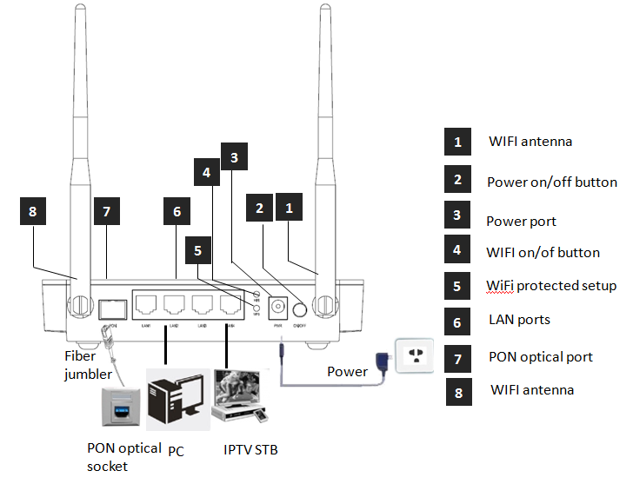
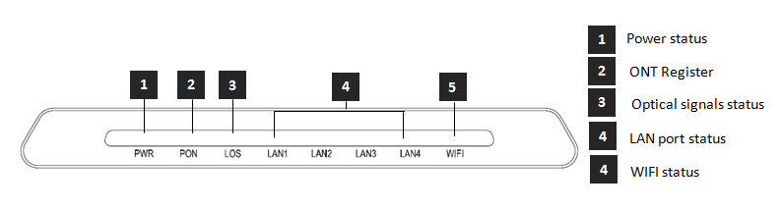
Indicator |  |  | Description
1 | PWR | Power status | On: The ONU is power on;  Off: The ONU is Power off;
2 | PON | ONU Register | On: Success to register to OLT  Blinking: In process of registering to OLT;  Off: In process of registering to OLT;
3 | LOS | EPON optical signals | On: Optical power lower than receiver sensitivity ;  Off: Optical in normal
4 | LANn | LAN Port status | On: Ethernet connection is normal;  Blinking: Data is being transmitted through the Ethernet port;  Off: Ethernet connection is not set up;
5 | WIFI | WIFI | Blinking：Data is being transmitted  On：Wi-Fi function Opens

Specification
Item | Parameter
PON Interface | 1 EPON optical interface  Meet 1000BASE-PX20+ standard  Symmetric 1.25Gbps upstream/downstream  SC single-mode fiber  split ratio: 1:64  Transmission distance 20KM
User Ethernet  Interface | 4*10/100M or 4*10/100/1000M auto-negotiation  Full/half duplex mode  RJ45 connector  Auto MDI/MDI-X  100m distance
Power Interface | 12V DC Power supply
PON  Optical  Parameter | Wavelength: Tx 1310nm, Rx1490nm  Tx Optical Power: 0～4dBm  Rx Sensitivity: -27dBm  Saturation Optical Power: -3dBm  Connector Type: SC  Optical Fiber: 9/125ɥm single-mode fiber
Data Transmission  Parameter | PON Throughput: Downstream 950Mbps; Upstream 930Mbps  Ethernet: 100Mbps or 1000Mbps  Packet Loss Ratio: <1*10E-12  latency: <1.5ms
Business  Capability | Layer 2 wire speed switching  Support VLAN TAG/UNTAG，VLAN conversion  Support Port-based speed limitation  Support Priority classification  Support storm control of broadcast  Support loop detection
Network  Management | Support IEEE802.3 QAM, ONU can be remotely managed by OLT  Support Remote management through SNMP and Telnet  Local management
Management  Function | Status monitor, Configuration management, Alarm management,  Log management
Shell | Plastic casing
Power | 4FE: <3.9W, 12V/0.5A power supply adapter  4FE+WIFI: <4.9W, 12V/0.6A power supply adapter  4GE: <4.3W, 12V/0.5A power supply adapter  4GE+WIFI: <5.3W, 12V/0.6A power supply adapter
Physical  Specifications | Item Dimension：160mm(L) x 120mm(W) x 32.5mm (H)  Item weight：0.2kg
Environmental  Specifications | Operating temperature: 0 to 50ºC  Storage temperature: -40 to 85ºC  Operating humidity: 10% to 90%(Non-condensing)  Storage humidity: 10% to 90%(Non-condensing)

WIFI Specification (Suitable for the WIFI devices)
Item |  | Parameter
Performance parameters | Operating Mode | Router or bridge
 | Throughput | IEEE 802.11b: 11Mbps  IEEE 802.11g: 54 Mbps  IEEE 802.11n: 300Mbps
 | Frequency | 2.412 ~ 2.472 GHz
 | Channel | 13*Channel, configurable to meet the standard of USA, Canada, Japan and China
 | Modulation | DSSS , CCK and OFDM
 | Coding | BPSK, QPSK, 16QAM and 64QAM
 | RF receive sensitivity | 802.11b: -82dBm @ 1 Mbps; -80dBm @ 2 Mbps;  -78dBm @ 5.5 Mbps; -76dBm @ 11 Mbps  802.11g: -82dBm @ 6 Mbps; -81dBm @ 9 Mbps;  -79dBm @ 12 Mbps; -77dBm @ 18 Mbps;  -74dBm @ 24 Mbps; -70dBm @ 36 Mbps;  -66dBm @ 48 Mbps; -65dBm @ 54 Mbps
 | RF output lever | 802.11b: 16.5 ±1dBm  802.11g: 13 ± 1dBm @ 54 Mbps; 14 ± 1dBm @ 48 Mbps; 15 ± 1dBm @ 6 ~ 36 Mbps  802.11n: 13 ± 1dBm @ 54 Mbps; 14 ± 1dBm @ 48 Mbps; 15 ± 1dBm @ 6 ~ 36 Mbps
 | Encryption Mode | 802.11i security: WEP-64/128, TKIP (WPA-PSK) and AES (WPA2-PSK)

Network application
Typical Solution：FTTH, FTTO
Typical Business：INTERNET, IPTV, VOD, IP Camera, WIFI
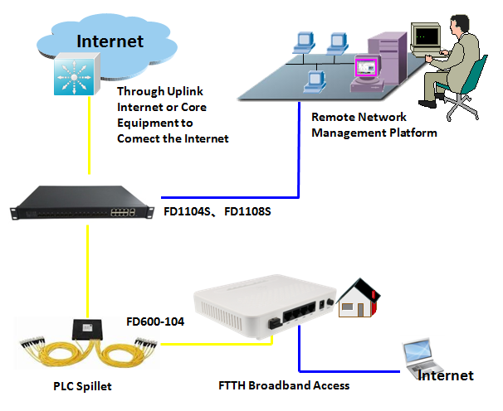
Figure: WDS600-104 Application Diagram

Ordering Information
Product Name | Product Model | Descriptions
4FE | WDS600-104F-HR220 | 4*10/100M Ethernet interface, 1 EPON interface, plastic casing, external power supply adapter
4GE | WDS600-104G-HR220 | 4*10/100/1000M Ethernet interface, 1 EPON interface, plastic casing, external power supply adapter
4FE+WIFI | WDS600-104FW-HR220 | 4*10/100M Ethernet interface, support Wi-Fi function, 1 EPON interface, plastic casing, external power supply adapter
4GE+WIFI | WDS600-104GW-HR220 | 4*10/100/1000M Ethernet interface, support Wi-Fi function, 1 EPON interface, plastic casing, external power supply adapter

