**1. Use Linux 6.1.99 kernel version and add ath11k related drivers**

**2. Use**

**QCN9074/hw1.0/2.7.0.1/WLAN.HK.2.7.0.1-01744-QCAHKSWPL_SILICONZ-1 firmware version**

**3. Copy the firmware to the directory/lib/firmware/ath11k/QCN9074/hw1.0/directory, as shown in the following figure**

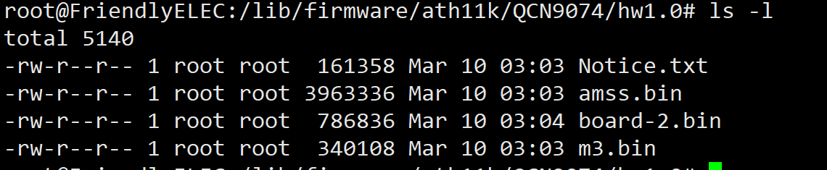

**4. Load the ath11k driver successfully, and the kernel prints as follows.**

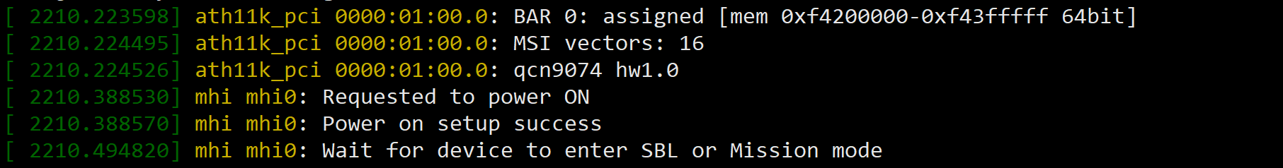



**5. Use ifconfig to check that wlan0 has been recognized.**

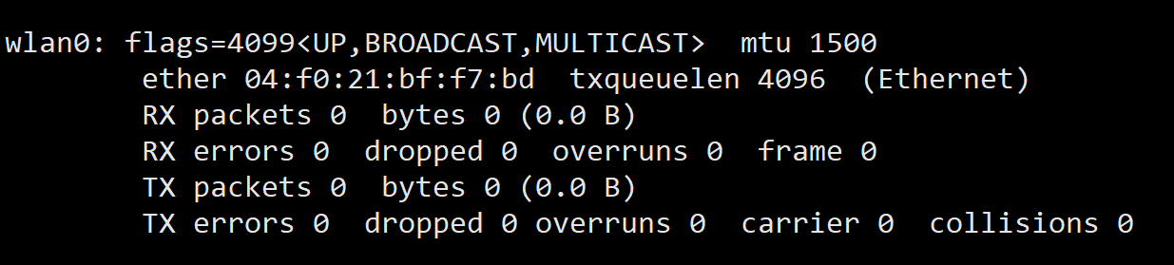

**6.Scan external WiFi using the WPA_CLI scan and WPA_CLI scan_desult commands, only 5G band WiFi can be scanned**

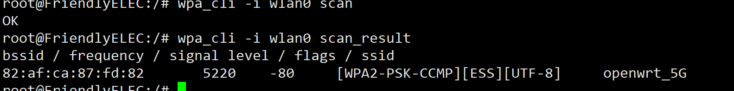

**7.Connect to the scanned 5G frequency band WIFI for normal communication.**

**8. According to the previously provided document, replace the relevant firmware. The document content is as follows, please use serial console:**

1.cd /lib/firmware  
2.mkdir ath11k && cd ath11k  
3.mkdir QCN9074 && cd QCN9074  
4.mkdir hw1.0 && cd hw1.0  
5.cp /directory/of/bdf.bin ./ (repeat this step for all above files)  
6.ln -s WLE3002HX_SPF11_4_2G.bin board.bin (for first attempt on symbolic link)  
  
To change board data files after first attempt:  
Change to 2G: ln -s -f WLE3002HX_SPF11_4_2G.bin board.bin  
Change to 5G: ln -s -f WLE3002HX_SPF11_4_5G.bin board.bin

**9. According to the understanding, WLE3002HX_SFP11_4_2G.bin needs to be soft connected to**

/lib/firmware/ath11k/QCN9074/hw1.0/下的board.bin

